**Migratory situation in June – Arrivals in Europe rise slightly**

2019-07-11

In June, the number of detections of illegal border crossings on Europe’s main migratory routes rose 6% from the previous month to around 8 300. The total for the first half of 2019 was nearly a third lower than a year ago at around 42 000.

**Eastern Mediterranean**  
The Eastern Mediterranean remained the busiest migratory route into Europe with nearly 4 000 detections in June 2019*.  
  
However, in the first six months of this year, the total number of detections in this region was down 16% from a year ago to close to 21 500.  
  
One out of four migrants detected on this route were nationals of Afghanistan, usually arriving by sea.

**Western Mediterranean Sea**  
The number of irregular migrants taking the Western Mediterranean Sea in June rose by 55% from the previous month to almost 2 350.

The total for the January-June period stood at more than 10 300, 27% less than in the same period of last year.

Nationals of Morocco, Mali and Algeria accounted for the largest number of detected migrants on this route in the first six months of 2019.

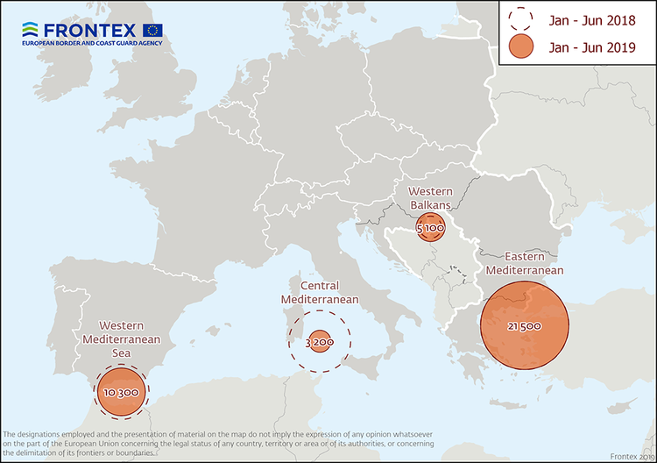

**Central Mediterranean**  
The number of migrants passing through the Central Mediterranean in June stood at 1 150, close to the figure in May.

The total for the first half of the year was 83% lower from a year ago at about 3 200.

Tunisians, Pakistanis and Algerians were the most represented nationalities on this route in the January-June period.

**Western Balkans**  
There were nearly 500 detections illegal border crossings recorded on this route in June. The total for the first six months reached nearly 5 100 or double the figure from a year ago.

Nationals of Afghanistan and Iran accounted for the largest share of migrants detected on this route.

*June 2019 data does not include the number of detections in Cyprus.

*Note: The data presented in this statement refer to the number of detections of irregular border-crossing at the external borders of the European Union. The same person may attempt to cross the border several times in different locations at the external border.*